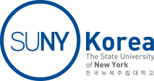
Student Application
SUNY Korea Library Assistants

[Personal Information]
Last Name |  |  | First Name
Date of Birth |  |  | Student ID No.
Phone |  |  | GPA | /4.0
Major |  |  | Entry Term
E-mail
Language | □ English  □ Korean | □ Beginner □ Intermediate □ Advanced □ Fluent  □ Beginner □ Intermediate □ Advanced □ Fluent
Please describe specifically how you are qualified for the position.
Please attach your time schedule for Fall 2018 below.

August 21, 2018

